MASINDI NEMBUDANI
ST10519562
ICE TASK 3: The proposal
PROJECT PART 1
SINDI’S GLAMOUR STUDIO (SGS)

1.OVERVEIW OF THE ORGANISATION
BRIEF HISTORY
Sindi’s glamour studio was launched when the owner was learning more about modern beauty standards. It started as a nail bar, but it grew more into a hair and nail studio
MISSION STATEMENT
Sindi’s glamour studio aims to make clients feel great about themselves, enhance one’s confidence and make clients feel free to communicate their dissatisfactions
VISION STATEMENT
SGS vision is to grow more and not only offer service to female but also become a unisex studio where male haircuts are provided. SGS aims to sell hair products in the future.
TARGET MARKET
Kids, Young adults and older women

2. WEBSITES GOALS & OBJECTIVES
OBJECTIVE
The website’s primary objective is to make it easier for clients to learn about the services offered and to advertise SGS online
GOALS
The goal is to raise awareness of the hair and nail industry. Permit clients to view the services that are offered and to make online appointment reservations. Promotes exclusive deals and promotions. Provide SGS’s location and contact details
KPIs
The quantity of visitors to the website, the quantity of reservations made online, client questions via the website and an increase in appointments at SGS

3. ANALYSIS OF THE CURRENT WEDSITE
The company does not have a website currently. Majority of clients discover SGS via social media and word-of-mouth
Advantages- good relations with neighbors and loyal clients
Weaknesses- minimal presence on the internet, online services and prices are difficult for clients to find.
Improvement opportunities -building a polished website will boost visibility, give client information and boost reservations

4 PROPOSED WEBSITE FEATURES AND FUNCTIONALITY
Home page- this page will show the overview of the company and feature eye-catching pictures of hairstyles and nails
About us page- shows information about SGS’s goals and objectives
Page for services - this page will display hairstyles and nails such as manicures, pedicures, nails made of acrylic or gel. It will also display the prices
Reservation page – online appointment scheduling will be available to clients, which will allow them to choose date, time and what there want to do but a 10% deposit should be included as booking fee
Gallery page- will show visuals of what we offer
Contact page – SGS’s location, phone number, email address and social media link will be on this page

5 DESIGN &USERS EXPERIENCE
The website will have modern and attractive designs that reflect beauty and professionalism. To fit the beauty theme soft colors like dark pink, white and baby blue will be used
The website will also be easy to navigate, fast, mobile friendly and full of aesthetically pleasing pictures of hair and nails.


 COLOUR PALETTE
6.TECHNICAL REQUIRMENTS
For clients to access Sindi’s Glamour studio online, a domain name like www.sindi’sglamourstudio.co.za will be used to host web services for clients
The website will be built using the following programming languages:
HTML -will create the page structure of the website
CSS -will style the website and add eye catching layouts, colors and fonts
JAVASCRIPT -will incorporate interactive elements like picture sliders and reservation form

7. TIMELINE &MILESTONES
Week 1: plan how to build our website and decide on what feature to include
Week 2: Design the structure of the website and make sketches
Week 3: Use HTML a to build our website and CSS to design our website
Week 4: Testing our website and add JavaScript features
Week 5: make changes, correct errors, and get the completed website ready for submission.

8. BUDGET
Domain name registration = R 150 yearly
Web hosting = R 100 per month
Website development= R5000
Maintenance and updates = R 300 per month
Total estimated budget =R5 550
9 REFERENCES
MDN Web docs, 2024. Web development Documentation. [online] Available at:<http://developer.mozilla.org> [Accessed 11 March 2026]
W3Schools, 2024. HTML, CSS and JavaScript Tutorials. [online] Available at:< http://www.w3schools.com > [Accessed 11 March 2026]
Google, 2024. Small business website design tips. [online] Available at: < http://www.google.com > [Accessed 11 March 11, 2026]

PROJECT PART 2
NDITSHE’S CAKES (NC)

- OVERVIEW OF THE ORGANISATION

BRIEF HISTORY
Nditshe’s cake was founded to offer local clients fresh, delicious and beautifully designed cakes for birthdays, weddings, graduations and other special occasions. NC prioritize high quality ingredients, unique designs and excellent customer service

MISSION STATEMENT
NC aims to satisfy customers by offering premium cakes and baked goods that elevate every occasion

VISION STATEMENT
By providing unique cake designs and first-rate service, Nditshe’s Cakes hopes to establish itself as a reputable and well-known cake business in the neighborhood

TARGET MARKET
People organizing birthday parties, couples preparing to tie the knot, families holding special occasions and businesses hosting events

- WEBSITE GOALS & OBJECTIVES
The primary object is to assist Nditshe’s Cake in expanding its clientele and business online.
Website Goals- to raise awareness, let clients see cakes and services that are offered, to promote catering services and cake designs, make it simple for customers to contact the business and to permit customers to order or get quotes online
KPIs or key performance indicators – an increase the websites visitors, an increase in the number of cake orders placed via the website, the quantity of questions sent via the contact page and positive comments and feedback

- CURRENT WEBSITE ANALYSIS
At the moment NC primarily uses social media and word of mouth to market its goods.
Advantages – superior cakes and baked goods. Sell innovative and personalized cakes. NC has relations with its customers
Weakness – limited online presence. The customers of NC have trouble trying to view the menu and cake designs. No online ordering system
Improvement Opportunities - make a polished website for business, give precise details about the cake-related goods and services and include an online ordering system.

- PROPOSED WEBSITE FEATURES & FUNCTIONALITYS
Home page – overview for Nditshe’s Cake, appealing pictures of cakes
About us page – the history of NC, mission, vision, details of the owner
Product or services page – list of cakes such as cupcakes, wedding cakes and birthday cakes including their prices. Details regarding personalized cakes
Gallery page – images of past cake designs and client orders
Contact page – Nditshe’s cakes email address, phone number and location
Orders page – online quote and cake order available to customers

- DESIGN & USER EXPERIENCE
The website must be aesthetically pleasing, straightforward and user friendly.
For the design features like vibrant and eye-catching colors that complement the theme will be used, high quality photos of cakes and baked goodies
Simple navigation to enable uses to locate information fast and customers can browse on their phones thanks to the mobile friendly design
COLOUR PALETTE

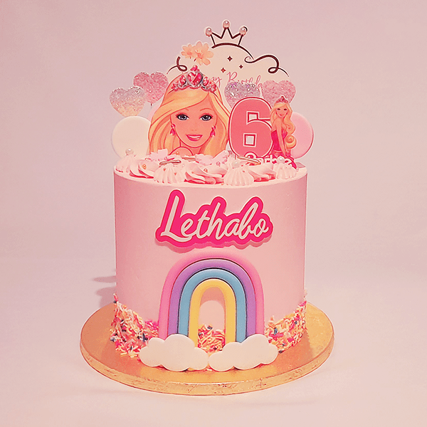

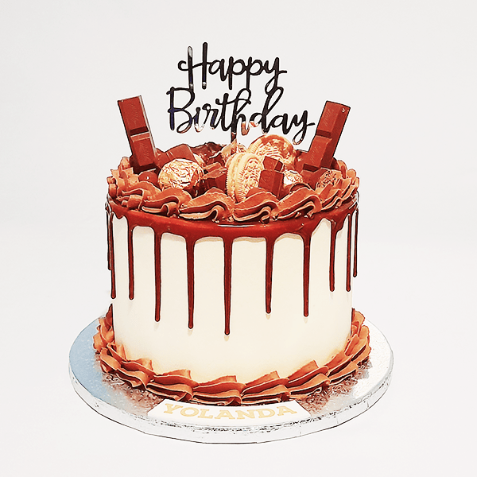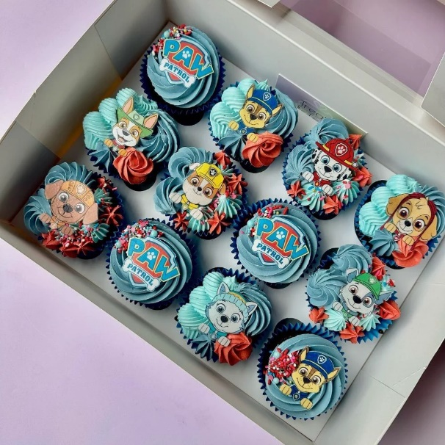

- TECHINCAL REQUIREMENTS

Customer to access Nditshe’s Cakes online a domain like www.nditshe’scakes.co.za will be used to host web services for customers

The following programming languages will be used:

HTML – will be used to build the website’s structure
CSS – will be used to design and style the website
JavaScript - will be used to incorporate interactive elements like pictures and forms

- TIMELINE & MILESTONES
Week 1: plan the content of the website
Week 2: create the website navigation and layout
Week 3: create a website with HTML, CSS AND JavaScript
Week 4: check the website for any omission and make necessary corrections
Week 5: final evaluation and project submissions
8.BUDGET
Domain registration = R150 yearly
Website hosting = R 100 per month
Website development = R 5 000
Maintenance and updates = R 300 per month

9.REFERENCES
W3Schools, 2024. HTML, CSS AND JavaScript tutorials. [online]. Available at:
< https://www.w3schools.com >. [Accessed 11 March 2026]
MDN Web Docs,2024. Web development documentation. [online]. Available at: < https://developer.mozilla.org >. [Accessed 11 March 2026]
Google developers,2024. Web development learning resources. [online]. Available at: < https://developers.google.com>. [Accessed 11 March 2026]

